Career Cluster Finder

By: Jeremy Goldman, NCC
Students: All 9th grade students
Sessions: 1 American Government session

ASCA Counseling Standards Addressed
A-A | A-B | A-C | C-A | C-B | C-C | PS-A | PS-B | PS-C
 | X | X | X | X | X

A:B2.7: Identify post-secondary options consistent with interests, achievement, aptitude, and abilities

A:C1.3: Understand the relationship between learning and work

C:A1.1: Develop skills to locate, evaluate, and interpret career information

C:B1.2: Identify personal skills, interests, and abilities, and relate them to current career choice

C:B2.1: Demonstrate awareness of the education and training needed to achieve career goals

C:C1.2: Identify personal preferences and interests influencing career choice and success

Maryland Career Development Standards Addressed
ST1-  A | ST1-  B | ST1-  C | ST1-  D | ST2-  A | ST2-  B | ST2-  C | ST2-  D | ST2-  E | ST3-  A | ST3-  B | ST4-  A | ST4-  B | ST5-  A | ST6-  A | ST6-  B
X | X |  | X

COMAR Standards Addressed
Goal 1: Facilitate personal and academic growth so that the student will:
 | (a) Understand all facets of the school environment.
 | (b) Understand individual rights and responsibilities.
 | (c) Demonstrate effective study skills.
X | (d) Engage in appropriate classroom behavior.
Goal 2: Encourage the development of educational and career decision-making skills so that the student will:
X | (a) Comprehend aptitudes, interests, and experiences as they relate to individual career development.
 | (b) Apply the steps of decision making to any situation.
 | (c) Develop an approved 4-year high school plan of study.
X | (d) Analyze various careers that are appropriate to an individual's aptitudes, interests, and experiences.
 | (e) Identify appropriate career opportunities.
 | (f) Select the most relevant educational or vocational training programs.
X | (g) Formulate and appropriately modify a personal career development plan.
 | (h) Demonstrate useful employment-keeping skills.
Goal 3: Promote the development of interpersonal skills so that the student will:
 | (a) Understand the effect of one's behavior on others.
X | (b) Demonstrate effective, interpersonal communication skills.
 | (c) Possess the knowledge and skill for resolving interpersonal conflict.

Formative Assessment:
Determine how many students actually completed the career cluster survey.

Enduring Life Skill(s)
 | Caring | X | Goal Setting |  | Responsibility
 | Commitment |  | Integrity |  | Self Discipline
 | Compassion |  | Kindness |  | Tolerance
X | Confidence |  | Perseverance |  | Understanding
 | Cooperation | X | Problem Solving
 | Courage |  | Respect

Results
Results Statements (As a result of participating in this activity, students will): |  | How Students Will Demonstrate Progress Toward Results: | Assessments Used With Each Result Statement:
1 | Understand that individuals can find a career to fit their personality and interest cluster. | Students will complete an assessment that informs them of possible fits for their cluster profile. | Students will create a work that persuades the audience to consider their cluster, including pertinent data.

Preparations

Complete the following preparations prior to introducing the activity to students:
- Reserve a computer lab in advance
- Have YouTube ready to show on the projector screen for students in the computer lab
- Grant permissions in Naviance Family Connection for students to complete the cluster finder assessment
- Supply enough copies of the worksheet and ensure that students have writing utensils available.

Resources
The following resources are used in this activity: (Activity Sheets and/or suggested supporting resources—full citation/source for all materials used and/or modified MUST be provided)
- Naviance Family Connection – career clusters assessment

Objective:
- Students will complete a career cluster survey to assess a possible interest area, identify key data about that interest area, and articulate what is appealing about careers in that field.
- Engagement (Hook): Show a YouTube video by searching for “consider a career in” with a filter of less than 4 minutes. Ask students why some careers may be overlooked. Introduce to students that they are going to take an assessment that will ask about specific interests, and to complete the assessment honestly and to be open-minded about the results, and to not overlook possible career fit options.

Suggested Instructional Sequence/ Session Activities
Session | Step | Responsibility | Action Steps
1 | 1 | Students | Log on to Naviance Family Connection. Under the “Careers” tab, click “cluster finder” and then click on the “Start Assessment” button. This should take a class approximately one 45-minute period to complete.
 | 2 | Students | Complete the career cluster finder (10-15 minutes)
 | 3 | Counselor | Inform students that they do not need to choose ONLY one of the six in each group. Students can check as many, or as few boxes as they feel represent tasks they would enjoy.
 | 4 | Students | Click on one of the top career clusters to explore subcategories and related careers.
 | 2 | Students | Students are to complete the worksheet, identifying three example careers in their cluster, average salary in Maryland, related educational concentration, and what is appealing about those careers.
 | 3 | Students | Plan and write a persuasive article or design a poster advertisement that encourages the audience to consider a career in their cluster.

Follow-Up Activities

Classroom Teacher Follow-Up Activities (Suggestions classroom teacher may use to reinforce student learning of Comprehensive Guidance Lesson concepts)
Encourage more thorough work – perhaps filming commercials or more involved research projects.

School Counselor reflection notes (to be completed after the lesson)
STUDENT LEARNING: How will students’ lives be better as a result of this lesson? E.g.
- In what ways has their feeling, thinking, acting changed?
- How will these changes help them to be successful in school/life?
SELF ASSESSMENT: How did I do?? E.g.,
- What did I “like” about what I did to facilitate student learning?
- What would I change about what I did if I could do this lesson over with the same class? When I “do” the lesson with another group?
IMPLEMENTATION PROCEDURES: How did the process work? E.g.,
- Which of the procedures were effective? Which were ineffective?
- What changes will I make in the procedures the next time I “do” the lesson? (e.g. involvement of students, time, materials, instructions, grouping of students)
- Did the assessment provide adequate information about ALL students’ performance?
- What do I need to change to better align assessment with what all students are expected to know and be able to do?

Name ___________________________________________ Date ____________

Today you will take an assessment to find career clusters that offer a good #PHSfit for your interests.
- From https://connection.naviance.com/PikesvilleHi , click on the “CAREERS” tab and then the link for “cluster finder.”
- Start the survey and check the box for ANY activities, terms, or high school subjects that interest you. This is not a forced choice; you may select as many or as few boxes as are appropriate for your interests.
- When you complete the survey, you will see three top clusters:

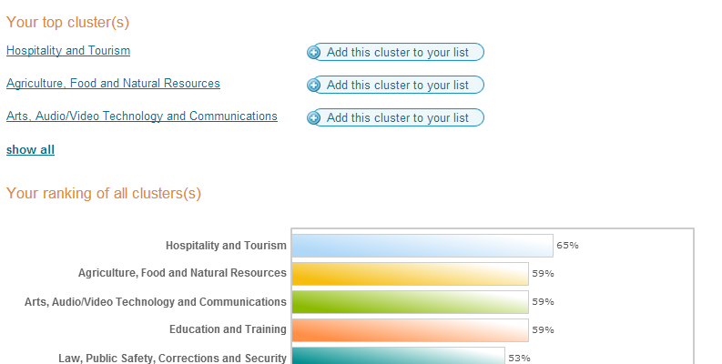
What cluster is your top result? ________________________
- What are three careers within that cluster that appeal to you?
a. | b. | c.
- What areas of study are related to those careers?
a. | b. | c.
- What is the average salary for those careers in Maryland?
a. | b. | c.
- Why would a person want to pursue those careers? What is appealing about them?
a. | b. | c.
- Either compose a persuasive article or design an advertisement poster that encourages your audience to consider your career cluster, mentioning your three example careers, and the educational path recommended to attain them.

