Getting to Know You Activity with a Beach Ball!

Here is a super simple and fun getting to know you activity!
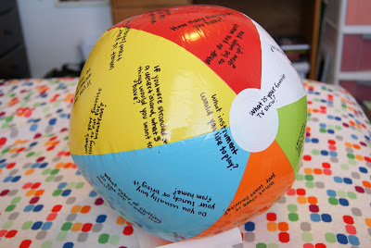
1. Get a cheap beach ball from the dollar store or Target $1 Spot.
2. Using a permanent marker cover it with getting to know you questions.
3. Throw the ball to someone. Tell them to answer the question that is touching their left/right thumb/index/middle/ring/pinky finger. For example, "Answer the question that is touching your right index finger".
4. After the question is answered the ball is thrown to another person, and so on.

Here are some questions you can write on the ball:
- What is your favorite TV show?
- What instrument would you like to play
- If you were stranded on a deserted island what 3 things would you want to have?
- What do you want to be when you grow up?
- What was the best gift you've ever received?
- Do you usually buy your lunch or bring it from home?
- What chore is your least favorite?
- What is your favorite game to play?
- What is your favorite cartoon character?
- How many siblings do you have?
- What do you like to learn about?
- What was your favorite part of summer?
- Name 3 things that make you happy.
- What is your favorite animal?
- What is your favorite book or book series?
- Would you rather be indoors or outdoors?
- If you could have a super power what would it be and why?
- What is your favorite toy to play with?
- What is your favorite color?
- Do you like sports? Which one?
- What job would you never do and why?
- What do you like to do for fun?
- What food will you never eat and why?
- What do you like to do for fun?
- Are you a cat-person or dog-person? Both? Neither?
- What famous person would you like to meet?
- What's your favorite school subject?
- When do you usually do your homework?
- What would you do if you won $10,000?
- If you could have any pet you want, what would it be?
- What king of movies do you like?
- Do you prefer white or colored socks?
- What was your favorite part of summer?
- Where were you born?
- What color of clothing do you like to wear the most?
- What is your favorite home-cooked meal?
- What is your favorite food?
- What is your favorite treat/snack?
- Do you like having dreams? Why or why not?
- What are you going to be for Halloween?
- What are three adjectives to describe you?
- Are you more a talker or a listener?
- What place would you like to visit?
- Do you have a favorite singer or band?
- Do you have a nickname? What is it?

