Self-Awareness

To know your emotions, thoughts, and how your behavior affects others.
Self-Management

To control your emotions, thoughts, and behavior in different situations and places. You will set and work towards personal and academic goals.
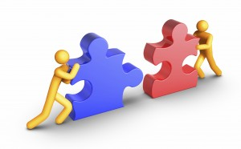
Social Awareness

To understand where others come from and their different backgrounds. You will empathize with others in your family, school, and community.
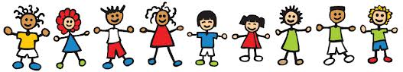
Relationship Skills

By communicating, being fair, and offering help. You will keep healthy relationships with different classmates, friends, and groups.
Responsible Decision Making

To make good respectful choices about yourself and others, based our school core values, safety, and past experiences. I will understand my actions have consequences. I will think about myself and others around me.

