Free School Counseling
Warm and Fuzzy
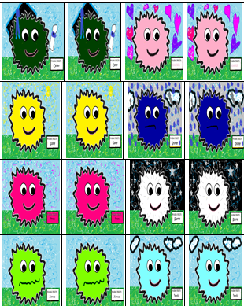
Guidance Lessons
If you like this set of lesson plans please see the entire eBook: Creative Warm and Fuzzy Guidance Lesson Plans by Dr. Michelle Stangline located on Creative Counseling Ideas and at www.CreativeCounseling101.

For over 750 pages of free counseling activities for school counseling, play therapy, sand tray therapy, and more, please visit my website:
www.CreativeCounseling101.com
By: Michelle Stangline. E.d.D., L.P.C.
Warm Fuzzy Elementary School Lessons
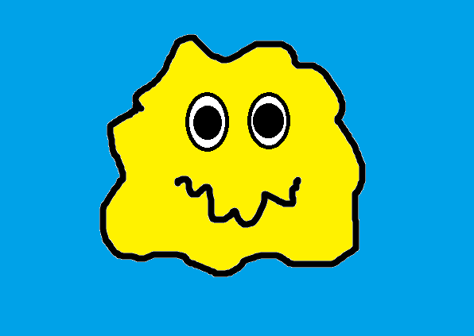
Rationale: I use this lesson at the beginning of the school year for each grade level (K-5th). I have cards for the lower grades and cards for the upper grades. I like to start the year off on a positive note to get students buying into the warm and fuzzy behavior model.
I read the story and then play the game with the students. I tell the kids that basically we have two choices in life. We can give warm fuzzies or cold prickly through our actions and behavior. The game helps students realize what behaviors are positive (warm fuzzies) and what behaviors are negative (cold prickly).
The Story of
Warm Fuzzy Elementary School
There was once a school called Warm Fuzzy Elementary School. All the Warm Fuzzy Friends went to this school. Warm Fuzzies are little balls of pure love and kindness. It was a wonderful school that was a safe and happy place for all children. All the Warm Fuzzy Friends were nice to each other and showed wonderful manners to their teachers, principals, and other adults in the building.
When the Warm Fuzzy Friends arrived at school each day they smiled and said a cheerful hello to each and every student in the class. They also made sure that they smiled and said hello to their teacher. After they made everyone feel warm and fuzzy, they sat down and did their class work quietly.
If a Warm Fuzzy Friends had a question he or she did not blurt, or yell out. They raised their hand when they needed something, or had a question. When a Warm Fuzzy Friend needed to use the restroom, or sharpen a pencil, they also raised their hand to ask permission. Can you raise your hand in a warm and fuzzy way?
When walking down the hall with their classmates they walked silently in line. They practiced the “Hip and Lip” technique. One hand stays on the hip, the other on the lip. Can you show me the “Hip and Lip” technique (Hand on hip other on lip)?
At lunchtime the Warm Fuzzy Friends showed polite manners in the lunchroom. They did not yell across the table, or throw food at one another. They talked quietly to the other Warm Fuzzy Friends at their table. Once they finished their lunch they cleaned up all their trash and pushed in their chair.
At recess the Warm and Fuzzy Friends made sure that everyone was included in the games. No one would ever allow another Warm Fuzzy Friend to be ignored at recess. Everyone felt included and loved, especially at recess time.
In the hallway the Warm Fuzzy Friends were kind and polite to one another. They smiled at all the Warm Fuzzy Friends they passed in the hall. No one would ever dream of saying mean things to another Warm Fuzzy Friend. And everyone in the school was considered a Warm Fuzzy Friend. No one was ever left out.
The Warm and Fuzzy Friends would never even think about gossiping, or talking badly about another Warm Fuzzy Friend. They would never want to hurt another Warm Fuzzy Friend’s feelings and make them feel bad.
Whenever the teacher was talking and teaching the Warm Fuzzy Friends made sure they listened to the teacher. They would never consider talking to another Warm Fuzzy Friend when the teacher wanted them to listen and be quiet.
So you see, in this school of Warm Fuzzy Friends everyone got along and everyone was kind to one another. The Warm and Fuzzy Friends listened to their teacher and minded their warm and fuzzy manners.
And guess what happened after that? The Warm and Fuzzy Friends became the smartest students in the entire world! This was all because they listened to their teachers and minded their manners. They had more time to learn than the kids at other schools who were not showing warm fuzzy behavior. And because they learned more they were smarter than all the other kids in the world!
The principal, Dr. Sweet Tart, decided one day to change the name of the school from the The Warm and Fuzzy Friends Elementary School to “The Smartest Warm and Fuzzy Friends Elementary School in the World!”
Do you have a Warm and Fuzzy Friends School? If not, what can you do to make your school a Warm and Fuzzy place to be?
We all have two choices to make each day…. Warm Fuzzies or Cold Pricklies. Are you going to give warm fuzzies, or cold pricklies to others today? The choice is yours.
Kindergarten Guidance Lesson
Warm Fuzzy Compliment Game
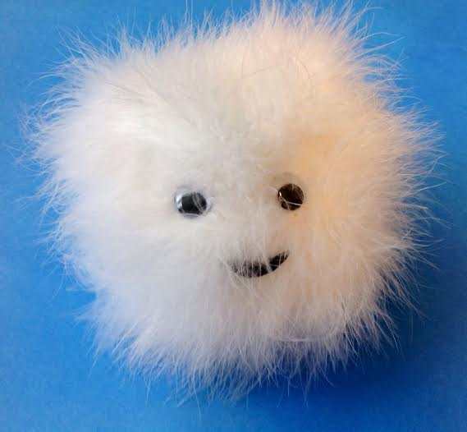
Rationale: I take one of my hand made warm fuzzy stuffed animals into kindergarten for a fun “get to know you and your friends lesson”.
Materials: Warm Fuzzy Item
Directions:
1. Ask the students to sit in a large circle.
2. Pick one student to start the game. This student will sit in the middle of the circle.
3. Tell the students that they will each get a chance to go around the circle and say something kind about the person sitting in the middle. Each student who is talking gets to hold the warm fuzzy stuffed animal.
4. If they cannot think of anything to say they are allowed to “pass.” I try to encourage statements about kindness and not about clothes, shoes, hair, etc.
5. Keep going until all students have had a chance to hold the warm fuzzy and make a statement. If they do not wish to make a statement they can say, “pass”.

1st Grade Lesson
The Warm Fuzzy Choice Game

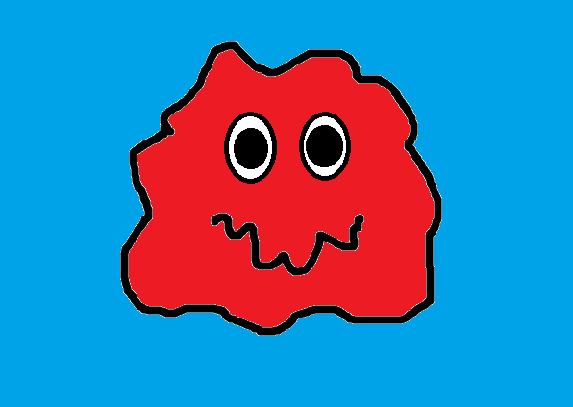

The Warm Fuzzy Choice Game

Cut out the Warm Fuzzy Choice Cards and Place on the Negative or Positive Choice Side Below:
Warm Fuzzy Choices Cold Prickly Choices

The Warm Fuzzy Positive Choices / Negative Choices Game
Chose which statement below is a positive (warm fuzzy), or negative choice (cold prickly):
The Warm Fuzzy Positive Choices / Negative Choices Game
Chose which statement below is a positive (warm fuzzy), or negative choice (cold prickly):
Running  in the  Hallway |  | Hitting or Punching |  | Sharing a Smile |  | Cleaning Up  a Mess You  Made |  | Saying Nice Things to Others
Listening to the Teacher Talk |  | Raising Your  Hand in Class |  | Walking in  the Hallway |  | Bullying or Teasing  Someone |  | Telling someone to stop bullying or teasing another person
Using Your Best Manners in the  Lunchroom | Doing your class work and homework |  | Kicking or Tripping Someone |  | Sticking Your Tongue Out At Someone |  | Playing with Everyone at Recess

Using Your Best Manners in the  Lunchroom | Doing your class work and homework | Kicking or Tripping Someone | Sticking Your Tongue Out At Someone | Playing with Everyone at Recess
Use these blank cards to make up your own warm fuzzy or cold prickly choices.

Warm Fuzzy Match Up Activity
All Grade Levels
Rationale: I allow students to pick a warm fuzzy friend from a basket I keep in my office. Once they pick the warm fuzzy they go to the Warm Fuzzy Hall of Fame to find out the name of the Warm Fuzzy they picked.
Materials: Warm Fuzzy balls in each color Glue
Wiggly eyes Wooden Platform about 2 inches by 16 inches
Name Plates (See Below)
Directions:
1. After I have had a session with a child, or if they just stop by to say hello, I offer a warm fuzzy pom pom ball to them.
2. Once they pick the warm fuzzy pom pom ball I ask them, “Who did you get?”
3. The student goes to the chart and matches the warm fuzzy from the basket to the warm fuzzy on the match board (See the picture of the wooden board for this).
4. I always ask the student what the warm fuzzy name means to them. For instance, if a student picks the warm fuzzy “Wish” I ask, “What do you wish for?” This opens the door to a lot of conversations.

2nd Grade Guidance Lesson
Warm Fuzzy Feelings Game
This is a great ice breaker game for students, teachers, and counselor to play at the beginning of school. It teaches the students to identify feelings and attach the feeling to a colored pom pom ball.
Materials: Assortment of Colored Warm Fuzzy Pom Pom Balls Basket or Jar for keeping the assorted Warm Fuzzies
Directions:
1. Tell the students you have brought some Warm Fuzzy Friends to play a game with.
2. Each student gets to pick a Warm Fuzzy out of the jar, or basket.
3. Using the Warm Fuzzy Feeling Chart identify the feeling and Warm Fuzzy on the chart.
4. After the student identifies the feeling and the Warm Fuzzy from the chart ask them to tell about a time when he or she had the same feeling.
5. Each time a student discusses a feeling add a coping skill idea to help with a feeling that is a negative one.
6. Continue to play the game for the entire guidance time.

3rd Grade Guidance Lesson
Fuzzy Feelings Charades
Rationale: Using the Fuzzy Feelings Charade Cards the students will act out the feeling written on the card.
Materials:
Warm Fuzzy Charade Cards
Directions:
1. Make two copies of the Fuzzy Feelings Cards. Cut out the Fuzzy Feeling Cards and place them in two stack. Mix the cards up in each deck.
2. Tell the students you are going to play a game of charades. Explain that with charades you cannot talk. The person trying to describe what the word means has to be silent and act the word out.
3. Write all the feeling words on the board to help the students guess the emotional words.
4. Divide the class into two teams. Each team will have 30 seconds to guess what the emotion is that the person is acting out.
5. Each time a team will send a member up to pick up a card. The person picking up the card will act out the emotional feeling. If the other team guesses within 1 minute they win 1 point. The team with the most points wins.

Warm Fuzzy Charade Cards
Happy | Sad | Mad | Bored | Hopeful
Fearful | Nervous | Surprised | Shy | Confused
Moody | Peaceful | Loving | Neutral | Grateful
Courageous | Annoyed | Excited | Kind | Helpful
Calm | Frustrated | Joyful | Angry | Greif

Fuzzy Feelings Chart Activity
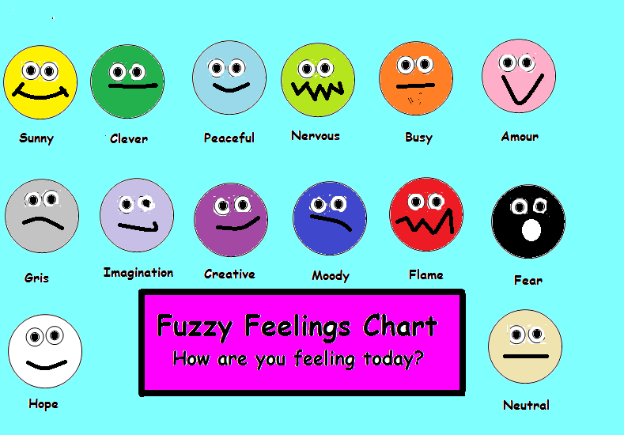
This chart will help children identify feelings based on the Warm Fuzzy pom pom balls. I print one for each of my classrooms to have and paste on the wall.

4th Grade Guidance Lesson
Warm Fuzzy Feelings Chart Game
This is a great way to get students to open up and identify feelings early in the year.
Materials: Warm Fuzzy Feeling Chart
Basket of assorted warm fuzzy pom pom balls
Directions:
1. Allow the student to pick a warm fuzzy from a basket filled with assorted warm fuzzy pom pom balls.
2.See what color the student picked and ask if they want to find out who they picked? If they say yes, go to the chart and tell them the name of the warm fuzzy color they chose.
3. I always ask the child a question relating to the name of the warm fuzzy color. For example, if a child picks the warm fuzzy named “Dream” I might ask, “What do you dream about”?

Fuzzy Feelings Chart

5th Grade Guidance Lesson
Fuzzy Feelings Self Portrait
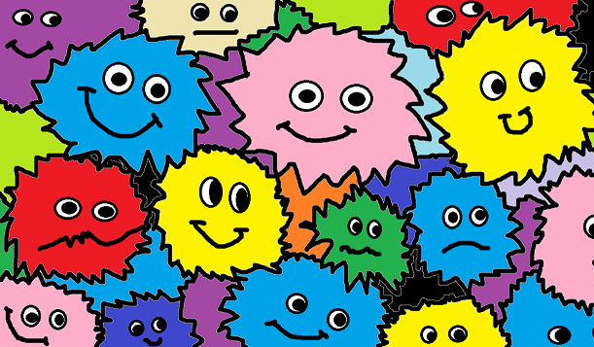
This is an excellent way to get kids in touch with their fuzzy feelings. I introduce the fuzzy friends chart to the students before offering this lesson.
Materials Needed:
Reuse the Fuzzy Feelings Chart in 4th Grade Lesson
Markers or Crayons White Paper
Directions:
1. Ask the students to make a list of all the fuzzy feelings they have felt in the past few days. Review the fuzzy feelings chart to remind them of the of the different feelings.
2. Each student will create a self portrait based on the different feelings they have experienced in the past few days.
3. Have students volunteer and describe the feelings that they have had during the week. Other students will learn that everyone has different feelings and that it is normal to have feelings go up and down each day.

Extra Guidance Lesson:
All Grade Levels:
Fuzzy Feelings Classroom Mural
This is a fun way for students to create a group mural of the fuzzy feelings experienced in class. Have each student paint or color their favorite fuzzy feelings on the mural. Hang the mural up in the room for the students to reflect back upon.
Materials:
12 feet of light colored butcher paper

Bullying Prevention Box:
Warm Fuzzies Random Acts of Kindness Box: Put a box in your school for students to put notes about other students who have shown a random act of kindness. Read a few each week on the announcements to promote “Random Acts of Kindness” in your school. Your principal will love it!

